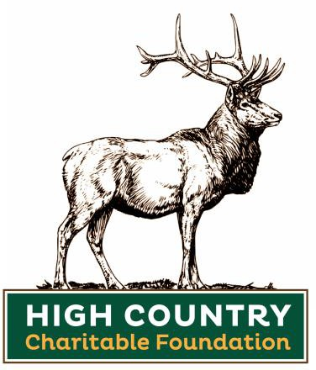

The mission of The High Country Charitable Foundation, Inc. is to provide funds to local non-profit organizations that provide for neighbors and animals in need in Avery County, North Carolina.

2022 GRANT APPLICATION FORM

The Foundation is grateful for your interest in receiving a Grant Award. We hope that the information below will guide you in completing your application.

2022 GRANT APPLICATION QUALIFICATIONS / REQUIREMENTS

- You must be a non-profit organization and a current copy of your IRS Tax-Exemption letter must be included with your application.

You are NOT eligible for a grant if your organization:
  - is not located in Avery County, NC
  - operates as a private non-operating foundation
  - if the grant is solely for operating expenses or to leverage a grant to another agency
  - if the grant is for a start-up organization (organization must be operating for a minimum of 2 years)
  - is engaged in any way in the promotion or advancement of political or religious beliefs
  - will transfer any portion of a High Country Charitable Foundation, Inc. Grant Award to any other organization
  - received a 2021 award and has not submitted a final or preliminary report by May 1, 2022
- The Foundation accepts one grant application from an organization. If there are multiple applications from the same organization, the organization’s director/principal decides which application to submit.
- Please submit application via email to whitney@highcountryfoundation.org. Applications must be received no later than June 30, 2022.
- All portions of the application must be completed.
- The Foundation expects that any funds awarded will be used solely for the purpose set forth in the Grant Application project.

PART I: YOUR ORGANIZATION

Organization Name:

Street Address:

City, State, & Zip Code:

Organization’s mailing address (if different from street address):

Amount Requested: $

Summarize Your Project In 50 Words Or Less:

Name of Key Contact Person:

Title:

E-mail address:

Organization Website:

Telephone: Fax:

Name of Additional Contact Person:

Title: Fax:

E-mail address:

Should changes occur in your organization or in the project for which the funds are sought, you must inform one of the Grants Committee Chairs as soon as possible.

- Is your project eligible for city, county, state, or federal funding?
If YES, please provide as many specifics as possible. YES NO

- Briefly summarize your organization’s background, goals, and current programs and how this grant would help your organization meet its goals.

- Describe your organization’s structure. Please attach a list of your Officers and Directors complete with addresses and phone numbers. Please indicate which Officers or Directors, if any, are paid by your organization.

- State what percentage of your organization’s total revenue is spent on overhead, such as rent, salaries and administrative expenses including office supplies, advertising, legal or professional fees.

PART II: PROJECT/PROGRAM (Please quantify whenever possible.)

- Describe the need that your organization will address.

- Describe the objective of the project and indicate how individual lives of the recipients will be improved and how many people/animals will benefit.

- If this project is part of a larger program, describe how a High Country Charitable Foundation Grant will make a difference within the overall project.

- What strategies will you employ to accomplish the project objective?

- Will you use volunteer help in this project? YES NO
If yes, how many volunteers will be involved and how will they be used?

- State who will conduct an evaluation to measure how well the project is meeting its objectives. How and when will this be done?

PART III: FINANCIAL INFORMATION

- Provide a complete project budget, including income and expenses, for the project for which you are requesting funds.

- List the names of organizations, both public and private, to which you have applied for support for this specific project/program. Also, show the amount requested and the status (pending, approved, or disapproved).

- If funds are to be used for contracted work or equipment acquisition, will competitive bids be obtained? If so, summarize the bidding process.

- Provide your most recent annual Financial Statement, including a balance sheet and statement of your income and expenditures. If unavailable, please explain.

PART IV: REPORTING REQUIREMENTS – 2021 Grant Recipients only

If you received a High Country Charitable Foundation Grant in 2021, you must submit a final or preliminary progress report for the project before submitting an application for 2022. The 2021 Grant Project Report (form can be found on our website) must be received no later than May 1, 2022.

PART V: SUBMITTING YOUR APPLICATION

Please submit:
- current 501(c)(3) document (tax exempt letter)
- your fully completed grant application
- your financial report
- list of your board of directors
- a complete project budget applied for in this application

I hereby certify that all the statements on this application and all the information contained herein are complete and true to the best of my knowledge and that the organization applying for this grant complies with all requirements for eligibility as found on page one (1) of this application.

Date

Signature

Printed Name

Title

This Application must be received no later than June 30, 2022

Please send your completed Application via mail, email or drop off at our office by the deadline.

The High Country Charitable Foundation, Inc.
610 Banner Elk Highway Banner Elk, NC 28604 (828) 898-3810
whitney@highcountryfoundation.org

